Coming soon!

Design Combine

Design Combine is a program that allows you to merge multiple PES together and save it as one file in a 4x4, 5x7, or 7x5 hoop.

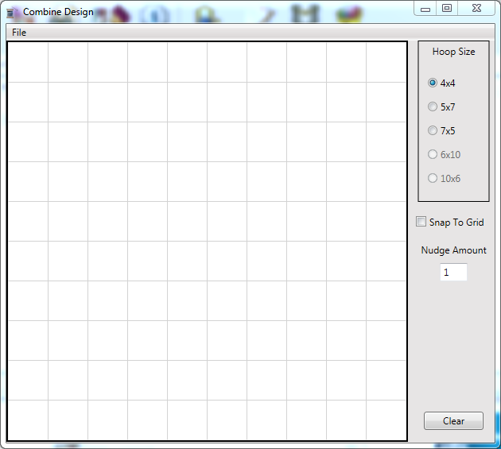

Combine Design allows you to choose your hoop size (6x10 and 10x6 are not available on this version and are greyed out) and opens into a grid in 10mm increments. Click on the circle next to the hoop size you would like to use.

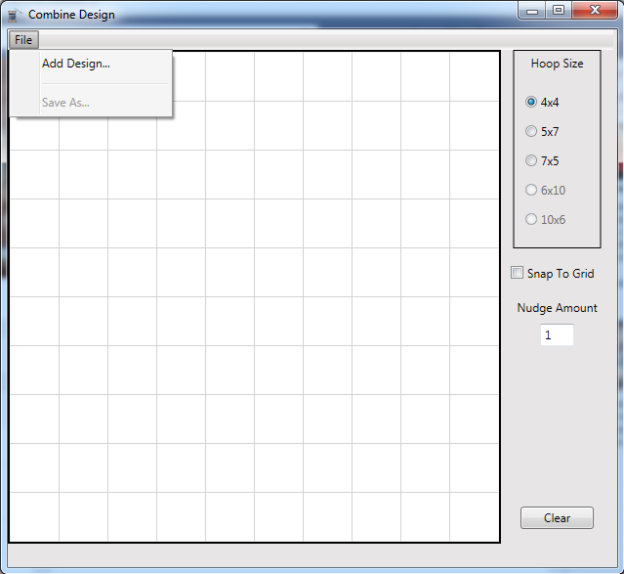

Click on the “File” button and a drop down menu will display where you can choose add design or save as. “Save As” is greyed out because you have no design on your hoop to save yet. Click on the “Add Design” button.

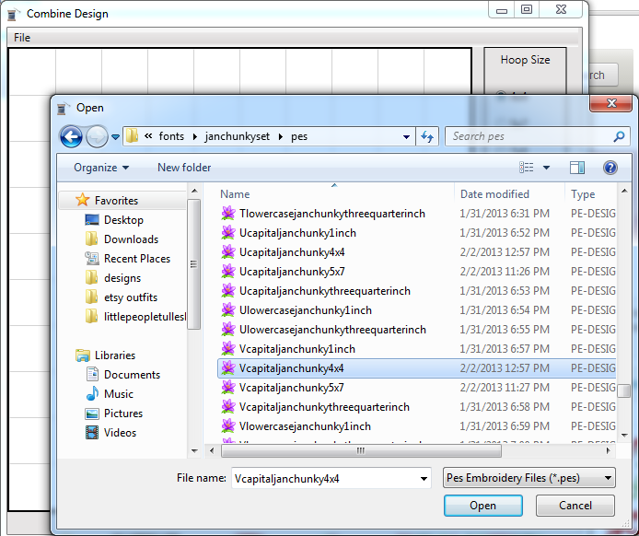Click on the “add Design” button and your file locations will display. Find the folder where you have your designs saved and locate the design you want to open first. Remember, the program will stitch in the order you open things so open the one you want to stitch first! Click on the file you want, I want the V 4x4, then click the “Open” button.

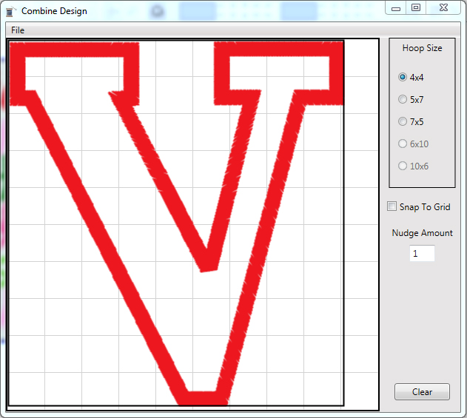Your file will open at the top left of your hoop. You can click on the file with your mouse and hold the mouse button down and drag the design around in the hoop. You can also click on the design and then use the arrow keys on your computer to move the design around.

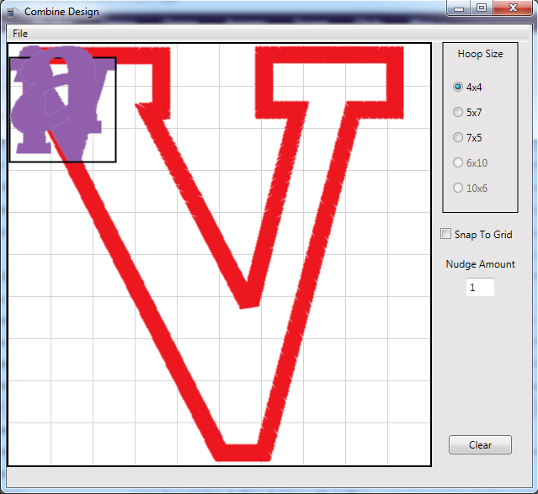You can add more design files to your hoop by repeating the previous step. You can also open your folder of designs and hold the control button down on your keyboard and click on multiple files and they will all open at once. They will all appear at the top left, so then just click and drag with your mouse until you have them where you want them.

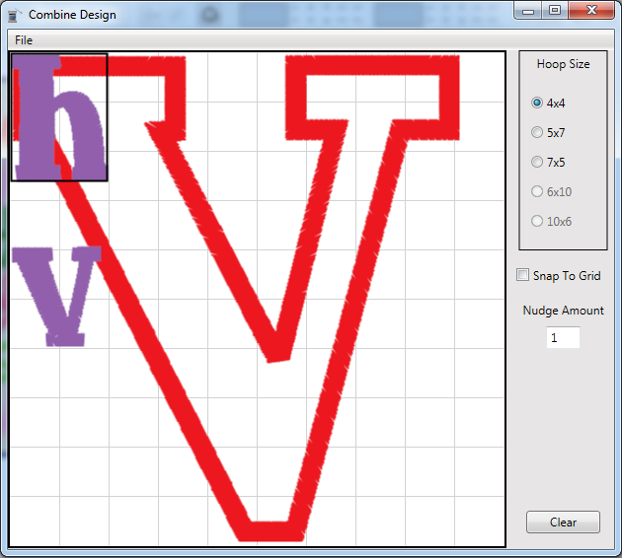If you accidentally add a design you don’t want (I added the h on accident) you can click on it with your mouse and it will get a black box around it so you know it is selected. Then, click your delete key on your keyboard and the design will be removed.

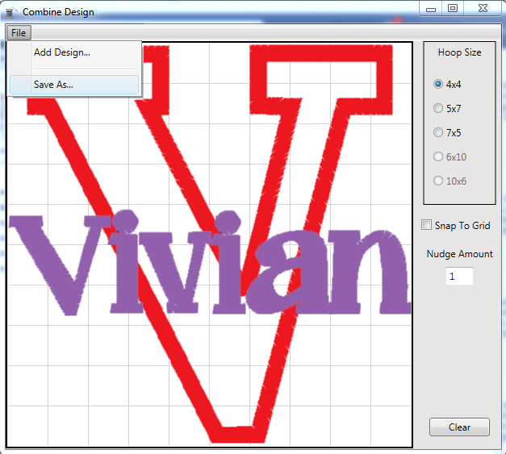

When you have everything in the design you want, click on the “File” button and then click on the “Save As” button.

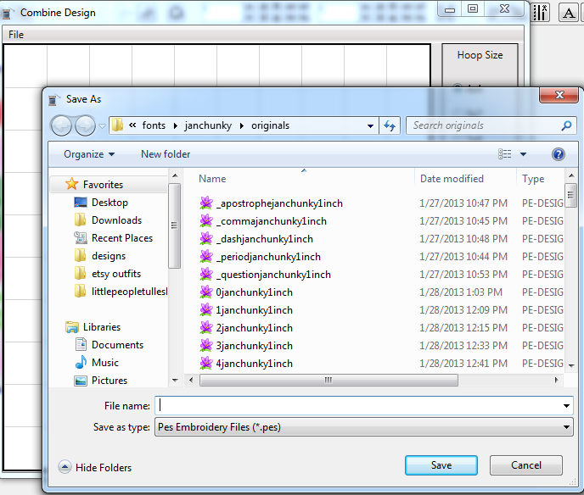A window will open with all of your locations to save your file. Select the folder you would like to save your combined design in and then name your file and click “Save”.





Other Information

Here is the menu from the side of the program and a brief description of what each setting or button does.

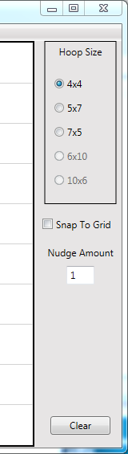

The snap to grid option makes the design

snap to the closest grid line to the design’s top

right corner. If checked, when a design’s

top right corner is close to a grid line, it will

pull the design right to that grid line and snap

it in place. It is used to make things line up

evenly.

The Nudge amount is the distance your arrow

keys will move a design. You can click on the

number and change it. The higher the number, the further the design will move with each click of the arrow keys.

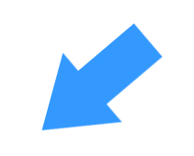



The clear button will delete all of the designs on your screen.



Things to consider about Design Combine

Before you purchase, please be sure this is the right software for you. This is a very inexpensive, but limited program. Please keep in mind the following limitations-

-This program only works with PES files

-This program only saves in 4x4, 5x7, and 7x5 hoop sizes

-This program does not resize or rotate designs

-This program does not rearrange stitching order or change thread colors

-This program does not take out satin stitches when layering appliques

The main purpose of this program is to allow you to merge multiple designs together and save as one file. The program is useful for you if you are wanting to-

-Combine letters from a digitized font to create and save a name

-Create a saying using letters from a digitized font

-Combine small fills to decorate around a word or design

-Combine individual small applique letters to spell a word

-Add a name to the bottom of a design with a digitized font

If you have any questions about the capabilities of Combine Design, please ask before you purchase at [dindin@bowsandclothes.com](mailto:dindin@bowsandclothes.com)